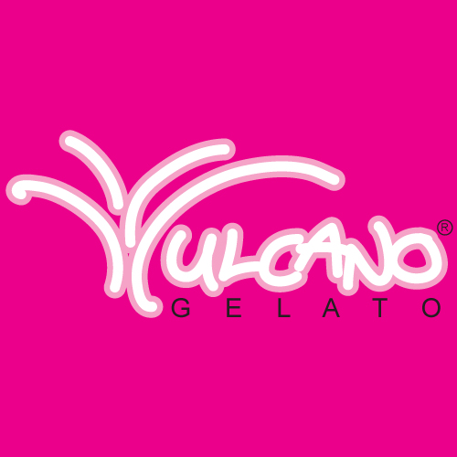

ALLERGY TECHNICAL SHEET
DAIRY FREE FLAVOURS:
Blood Orange, Coconut, Dark Chocolate, Forest Fruits, Lemon, Limoncello, Mango, Passion Fruit, Pineapple, Pomegranate, Raspberry, Red Bull, Strawberry, Watermelon.
GLUTEN FREE FLAVOURS:
Apple Pie, Baileys, Banana, Blood Orange, Blue Heaven, Bounty, Boysenberry, Bubble Gum, Butter Scotch, Cherry Ripe, Choc Chip, Choc Mint, Chocolate, Coconut, Coffee, Dark Chocolate, Ferrero Rocher, Forest Fruits, Hazelnut, Honeycomb, Kinder Surprise, Lemon, Limoncello, Liquorice, Mango, Nutella, Passion Fruit, Peanut Butter Crunchy, Pineapple, Pomegranate, Pistachio, Rainbow, Raspberry, Red Bull, Rum&Raisin, S/berry and Cream, Salted Caramel, Snickers, Strawberry, Toblerone Dark, Turkish Delight, Vanilla Bean, Vanilla Boysenberry, Watermelon, White Choc Raspberry Swirl.
NUT FREE FLAVOURS:
Apple Pie, Baileys, Banana, Biscoff, Blood Orange, Blue Heaven, Bounty, Boysenberry, Bubble Gum, Butter Scotch, Cherry Ripe, Cheesecake, Choc Chip, Choc Mint, Chocolate, Cinnamon Donut, Coconut, Coffee, Dark Chocolate, Forest Fruits, Honey Comb, Lemon, Limoncello, Liquorice, Mango, Mint Oreo, Passion Fruit, Pineapple, Pomegranate, Rainbow, Raspberry, Red Bull, Rum&Raisin, S/berry and Cream, Salted Caramel, Strawberry, Tim Tam, Turkish Delight, Vanilla Bean, Vanilla Boysenberry, Watermelon.
PLEASE NOTE: COCONUT IS NOT DEFINED AS A NUT.
FLAVOURS THAT CONTAIN COCONUT ARE: BOUNTY, CHERRY RIPE, COCONUT.
EGG FREE FLAVOURS:
Apple Pie, Baileys, Banana, Biscoff, Blood Orange, Blue Heaven, Bounty, Boysenberry, Bubble Gum, Butter Scotch, Cherry Ripe, Cheesecake, Choc Chip, Choc Mint, Chocolate, Coconut, Coffee, Dark Chocolate, Ferrero Rocher, Forest Fruits, Hazelnut, Honey Comb, Kinder Surprise, Lemon, Limoncello, Liquorice, Mango, M&M’s, Mint Oreo, Nutella, Oreo, Passion Fruit, Peanut Butter Crunchy, Pineapple, Pomegranate, Pistachio, Rainbow, Raspberry, Red Bull, Rum&Raisin, S/berry and Cream, Salted Caramel, Snickers, Strawberry, Toblerone Dark, Turkish Delight, Vanilla Bean, Vanilla Boysenberry, Watermelon, White Choc Raspberry Swirl.
PLEASE NOTE
ALL FLAVOURS may contain traces of NUTS, EGG & DAIRY.

